*Name: Chloe Yuen*

*Candidate Number: 198893 | Date of Submission: 15/11/2018*

*Coursework 1 -Creating a website and an animation*

*Module Title: Introduction to Multimedia*

*Degree Title: Computing for Digital Media BSc*

Table of Contents

1 Introduction 2

2.1 Website Development 3

Home Page 4

Image 4

Layout 5

Theme 7

Navigation Bar 8

Video Greetings 9

Hobbies 10

Coursework Page 11

Drop-down menu 11

Slideshow 12

Problems I encounted 13

Conclusion 13

2.2 Animation Development 14

Conclusion 15

3 Conclusion 16

4 References 16

UseD to create website: 16

Used to create animation: 16

Photos used: 16

# 1 Introduction

This report outlines the work carried out as a part of the Introduction to Multimedia module.

The aim is to create a website and an SVG animation. This report will demonstrate how the project was produced- decisions choices, problems encountered, tutorials used and overall development.

The website will be comprised of the following pages (as required):

* Home Page
* Video Greetings Page
* Hobbies Page
* Coursework Page
* Vector Animation Page

My SVG Animation will have to play a vector animation with the given sound file. The animation has to cover the following criteria:

* One bitmap image
* Drawn vector graphics object
* 2 animated vector objects in the scene
* Animation includes shape, motion and colour change
* Reasonable levels of synchronisation
* Animation last for at least 10 seconds
* Good technical execution

# 2.1 Website Development

I used WebStorm IDE to code this project as it highlights missed closing tags, has an autocomplete feature, a colour picker and has a quick way of opening your webpages in a browser.

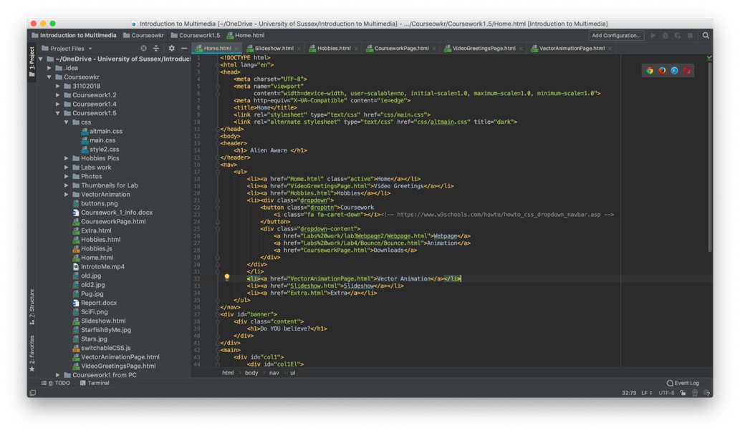

Figure 1 WebStorm IDE

I often used **Google Chrome** whilst testing. The reason I used Chrome was because it has an easy to use inspect tool for debugging my webpage. However, I’ve tested my website on all major browsers (IE, Firefox, Safari, Opera).

## Home Page

The Home page is the first page that the user will see. Therefore, this page should be the most eye-appealing webpage that encourages the user to discover more about the website.

This page started from a basic HTML template learnt in Lab 3 – a title, header, body, footer.

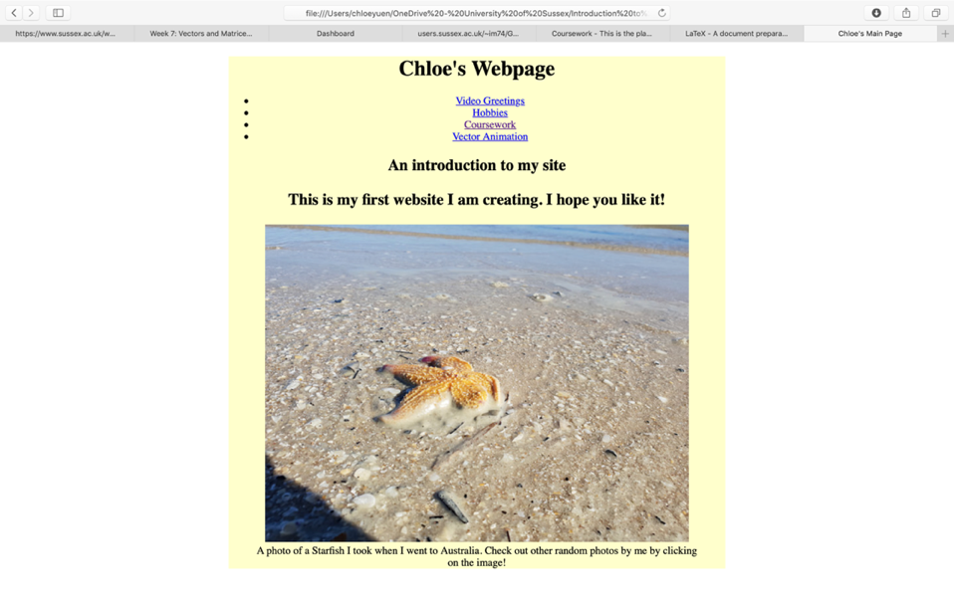

Figure 2 Starting out

A basic CSS file from Lab 3 (this is why the background is yellow) was used to start. Basic styles were added (font type, text size, etc). This was done by stating the tag (e.g. p for paragraph) then stating the style wanted (font-family: Arial).

Helvetica Neue was decided as the font; this was because of its modern design. The header was made bigger so it would stand out from the page and the user would know what page they are on.

### Image

Further on in development, it was discovered that a photo that could be attributed was needed instead of using a personal photo. Flickr was used to find the photo, as it contained a huge range of images which can be filtered so it only contains images that can be used under certain Creative Commons Licences.

This means the photo can be used, if it is correctly attributed, used for non-commercial use and won’t be changed (no derivatives)

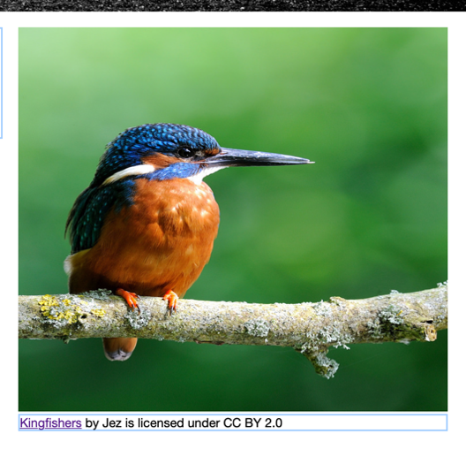 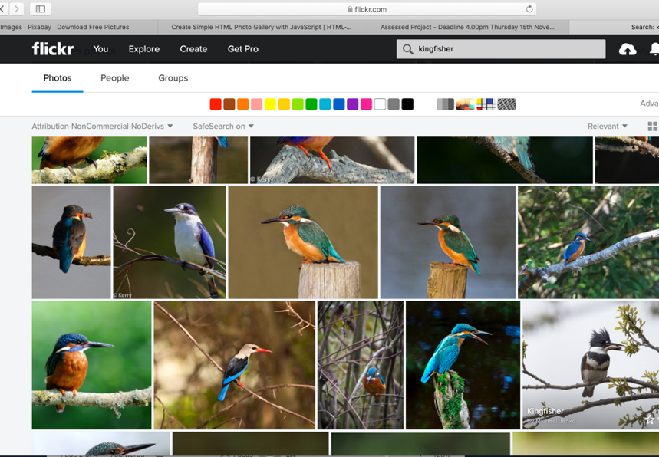

Figure 3 This was the photo I chose along with the caption I added - https://flic.kr/p/nQ49fW

Figure 4 Finding an image

The photo was linked through selecting the image or selecting the link on Kingfishers.

Once the space theme was decided, this [image](https://flic.kr/p/XJok6b) of a solar eclipse was used. An extra [image](https://pixabay.com/en/science-fiction-cover-futuristic-1999495) was also added to match the theme as well. The Sci Fi image did not need attribution as it is under CC0.

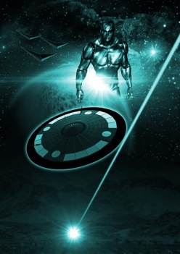

Figure 5 Sci Fi image



Figure 6 Solar Eclipse image with caption

### Layout

It was decided that the introduction text was to be on the left hand side of the webpage and the picture was to be on the right hand side of the webpage. This design was chosen as it allowed the user to see all the content at once instead of scrolling. This layout is also structured like this so the page does not look chaotic with images and text.

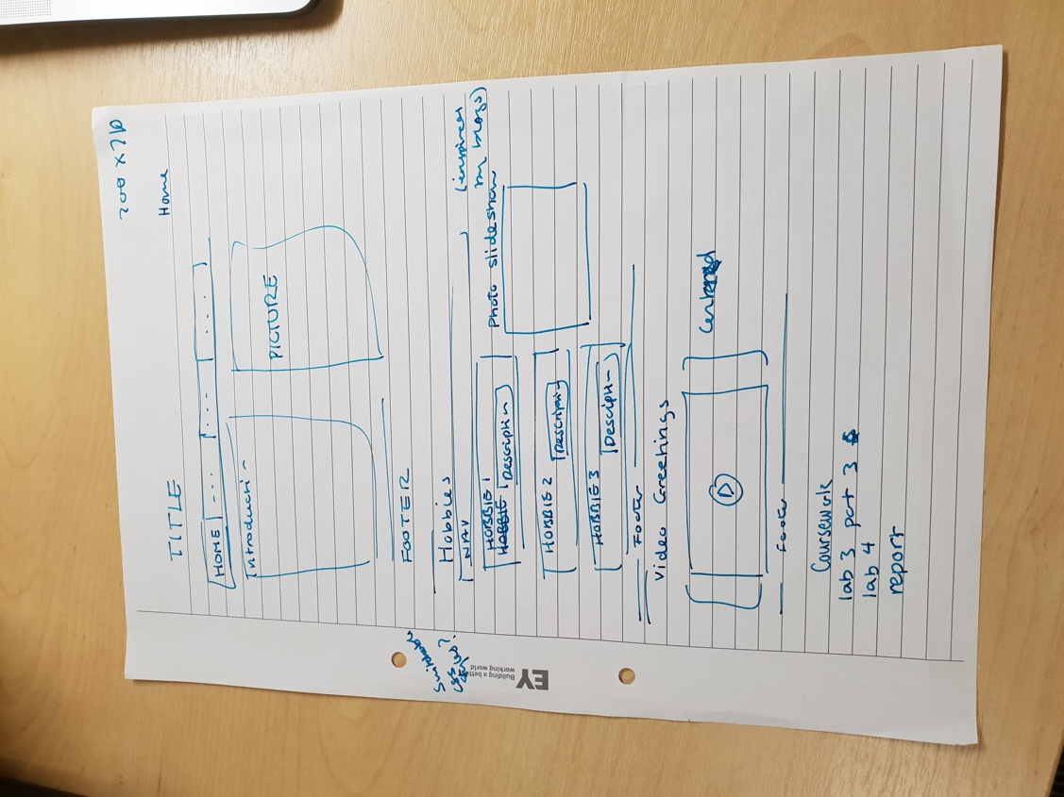

Figure 7 Rough sketch of layout

This w3schools tutorial was used: <https://www.w3schools.com/css/tryit.asp?filename=trycss_website_layout_blog>

The webpage is laid out in columns. The first column contained an element (the introduction text) and a second column that contained the photo.

#### Responsive Web Layout

Since browsing sites is now often done on a mobile, a responsive layout to the webpage seemed appropriate. Flexbox was used as it provided an easy solution for the elements to change position on the page depending on the width of the screen. This was learnt from a flexbox guide by [CSS-tricks](https://css-tricks.com/snippets/css/a-guide-to-flexbox/). Flexbox can move an element below another element or make the element smaller if the screen size is narrower. Flex-wrap was used so the photo would move below the introduction text if the screen shrunk to a certain width.

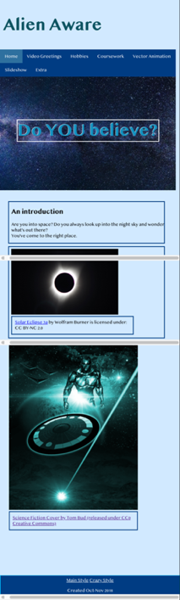

Figure 8 Webpage on a narrower screen (grey lines from screen capture)

#### Banner

The banner is used to make the text stand out to the user and give them an idea of what the website is about. The banner would be below the navigation bar and will have a piece of text overlaying it. There is a banner id, which has the width of 100% so it covers the full width of the page (like a banner). The background is sourced by an image (the space image). The overlay is an element over the banner.

Tutorial used:

<https://www.codecademy.com/courses/learn-css/lessons/box-model-intro/exercises/box-model-intro?action=resume_content_item>

Once the space theme was decide, a night sky image was used for the banner background.

The [Pexels](https://www.pexels.com/photo/blue-universe-956981/) website good for finding images, as it has a library of images under CC0 which means it is free to use without attribution.

## Theme

Near the end of development, a theme was decided to be added to th website as everything was random. In retrospect, the theme should have been considered at the start of development. This would give the website direction and allow for a plan to be created on how the site would look before programming it.

The theme was inspired by a show called the X-files. This show is primarily about the existence of aliens and this is what the website is based on and the subject of astronomy in general.

The colours of the website are shades of blue as it was appropriate for the theme of space.

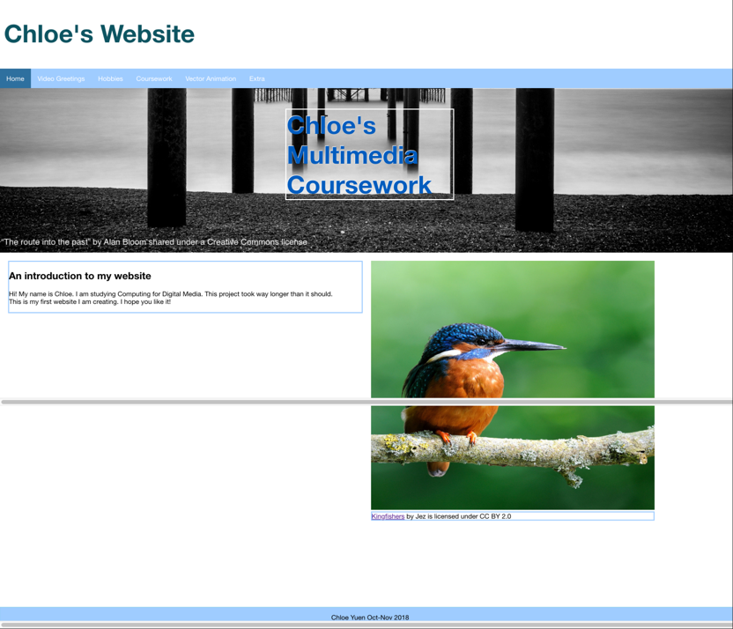

Figure 9 Before theme

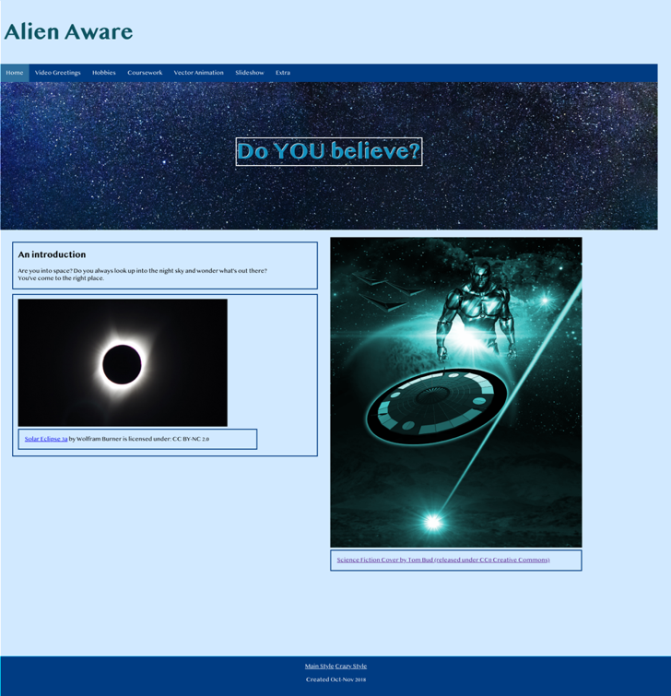

Figure 10 Final Webpage

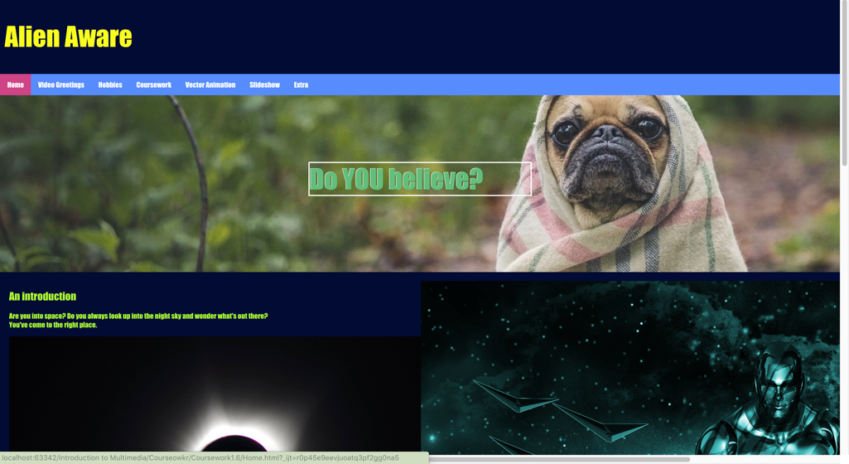

Figure 11 Alternative CSS style

To add extra functionality, an alternative CSS style was added. This made the background darker, mad the navigation bar and text different colours and made the banner a dog. This style is called the ‘crazy style’ and has a link to it in the footer.

This is done by adding a link to a JS file in the HTML. This changes the CSS link on the webpage to be sourced by the other CSS file.

## Navigation Bar

A top navigation bar was decided as items are easy to read and will always be on the same place on the page. The top bar is used instead of a side bar as contents were already in columns and the navigation bar may cause crowding. A top navigation bar is also the most popular type, therefore it gives familiarity to the user and they are most likely able to operate it quickly and effectively without confusion.

The navigation bar was learnt through this w3schools tutorial - <https://www.w3schools.com/howto/howto_js_topnav.asp>

The HTML navigation list was already set up with links, however no CSS was written with it. The tutorial demonstrated how to add a bar with all the items within it. The tutorial also showed how to create the hover feature, so when the user’s mouse is on top of the item, it will change colour. To highlight the current page, a class called active (this class changes the colour of the current item) was used. For each page, I added the active class to the appropriate navigation item. .active changed the colour of the item so the element that the user was pointing at was distinct.

(The navigation bar was coded using a div tag with a ‘nav’ id, which was shown in Lab 3. Ultimately the nav tag was used as it helps distinguish that it is the navigation bar for the site. Using a nav tag is also helpful for people who use a screen reader to navigate around the website).

At the very end of my development, I decided to add sound when rolling over buttons. I had an onmouseover=”playsound()” attribute in the item tag. This calls the javascript which plays the audio.

## Video Greetings

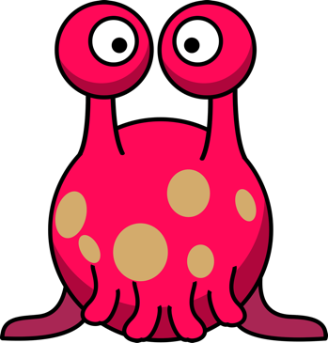The video was created using iMovie. The video was inspired by the last slide on the multimedia presentations that end with “Bye”.

iMovie sound samples was used for the video. A digital beep was first used for the start of each slide, however, the squeaky toy sound was more humorous. A ‘Brontosaurus wail’ was found as a sample and it was added to the video. This was paired with a dinosaur image on [Pixabay](https://pixabay.com/en/photos/dinosaur/).

Figure 13 An alternative option

Figure 12 The dinosaur image I used for my video

When the space theme was chosen, there was a decision whether to change to this image of an alien to match the theme, however it was finally decided to keep the dinosaur image as it worked with the sound.

A video tag with the control attribute was used. This allowed for the video to have controls such as pause/ play, mute button and making the video fullscreen.

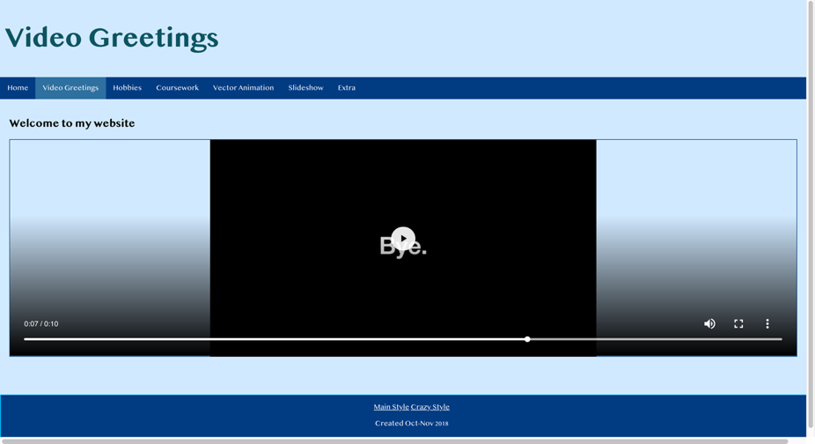

Figure 14 Video Greetings Webpage

## Hobbies

A [CodeAcademy](https://www.codecademy.com/courses/learn-css/lessons/css-grid-ii/exercises/justify-content?action=resume_content_item) tutorial uses a design that split elements into cards; this design showed a clear and more interesting way display information.

This required creating a class called Card in CSS that defines what the card will look like (flex-wrap feature was also added so it will be listed as a column of elements). In HTML, each hobby was split into div tags with the class Card. This meant each element was separated. In the CSS, it defined was a Card would look like.



Figure 15 Beginning of the Hobbies Page

#### Hobbies Slideshow

Instead of having just one image, a photo album was used instead

This tutorial was followed: <https://www.w3schools.com/howto/howto_js_slideshow.asp>

There was a slide class (this is for each image in the slideshow). Each slide has an opacity of 0, until it is ‘showing’. It also has a fade transition, this is done by changing the opacity. The HTML file links to a Javascript file that changes to the next slide after a set amount of time. The slide that is showing, has the ‘showing’ class applied to it, which changes the opacity.



Figure 16 Final Hobbies page

## Coursework Page

The same [CodeAcademy](https://www.codecademy.com/courses/learn-css/lessons/css-grid-ii/exercises/justify-content?action=resume_content_item) tutorial used in the Hobbies page was used again for the card design. There was to be a Card for each piece of Coursework. Each item has thumbnail and a link to download a zip file of the work.

The tutorial uses a grid system to layout out the items. As all items are within the main tag, the CSS for the main tag defines the grid system. Each item is split by a div tag (with a class that defines the card). Each item also has a description (which is another class) that allows for download links below each thumbnail.

### A screenshot of a computer Description automatically generatedDrop-down menu

Figure 17 Drop-down menu

A direct link to the lab work was also decided. A dropdown bar within the navigation bar links to the lab work.

A [w3schools](https://www.w3schools.com/howto/howto_css_dropdown_navbar.asp) tutorial is used to create a dropdown menu. In the navigation bar, there is an item called Coursework, this is a button which, when hovered over, will display the dropdown menu with the links to the coursework. The content (the links in the dropdown menu) has a display of none until it is hovered, then it will be displayed. Each class for the dropdown menu defines how it is shown: the colour of the text and the background colour of the item.



Figure 18 Coursework Downloads Page

## Slideshow

There was an experimentation with Bootstrap following this [tutorial](https://getbootstrap.com/docs/4.0/components/carousel/) to create one (The ‘Extra’ tab is the outcome of this). However, a slideshow without using Bootstrap was also developed. This [tutorial](https://www.w3schools.com/howto/howto_js_slideshow.asp) by w3schools was used to create this slideshow. All the JavaScript and CSS are within the HTML file as this was an extra added to the website and no more files needed to created.

Each slide has a photo and shows the slides number on the top left corner and a caption text at the bottom of the photo. Like the Hobbies slideshow, all photos are defaulted not to be displayed. The Javascript then changes a slide’s display to show it. The Javascript keeps track of the slide number so when the next or previous button is clicked, the related slide is shown.

Photos from Pixabay were used (as it is under the CC0 which means it is free to use without attribution).



Figure 19 Slideshow Page

### Problems encounted

When testing the website on the lab computers, the font (Helvetica Neue) would not work. This may be because it is installed by default on OSX but not on Windows OS. Therefore, Arial was used, as this font is quite widespread. However, later on when I had decided on a theme, I found Telugu MN, which was appropriate for my Alien themed website and it worked on both Windows 10 and OSX when tested. However, as a backup Arial is the second option if the font Telugu MN does not work.

There was a problem with the navigation bar colour on the ‘Coursework’ tab when testing on Internet Explorer. This was because Internet Explorer doesn’t understand ‘inherit’ in CSS which was used to keep the same background colour as the other items in the navigation bar. This was fixed by stating the colour directly instead of using ‘inherit’.

Another problem with Internet Explorer was with the Hobbies page, the images were not showing on the slideshow. This problem was solved by changing the jpeg images to bmps.

## Conclusion

This project has reached its aim and has met all basic specification with added functionality.

#### Added functionality:

* Navigation bar
  + Rollover buttons – the item is highlighted when the mouse pointer is over the element and a sound effect plays
    - A drop-down menu appears when the mouse pointer is over the Coursework tab
* Slideshows
  + An automatic slideshow on the Hobbies Page
  + A navigable slideshow with buttons on the Slideshow Page (extra material)
* Switchable CSS style
  + In the footer, there is an option to change to another style
    - This changes the background colour, navigation bar colour, text colour.
    - This also changes the banner on the Main Page
* Responsive Web Layout
* Tested on major browsers – Google Chrome, Safari, Firefox, IE11 and Opera.

# 2.2 Animation Development

The bouncing ball animation learnt in Lab 4 was built upon. This gave a good base to start with. To turn it into something with more context and narrative, the animation was going to be based on a person playing with a bouncing ball which changes shape, size and colour (to match the criteria). The ball will start in the person’s hand then be thrown up and start bouncing. The ball changes its features depending on the number of times it has been bounced.

The ball changes are used using ball.animate().

If the colour of the ball was to be changed to blue, put fill: blue’ in the animate brackets, specify how long it will take to animate the change, then use ‘ease in’, ‘ease out’ or ‘linear’- this speeds up or slows down the animation at the start of near the end (this was useful for creating realistic behaviour for the motion of the ball).

To change the size of the object, ’transform’ was used, then the size change, within the animate brackets. This is done to the ball and also to the UFO image.

To move the object, the object’s new coordinates (in x and y) was used.

A sun was added that beats to make the synchronisation with the music more obvious. Some clouds were also added to the picture to embellish the set of the animation.

To give the animation a narrative and add more excitement to just a bouncing ball and since it was recently decided on the alien theme, the ball would change to a UFO and fly off; the person would be abducted and is seen floating upwards.

One of the main problems that arose, was lag. The animation would start slowing down after a random number of seconds. This was resolved by making the functions be called sequentially so only one function is running at one time instead of multiple functions trying to run simultaneously.

For added functionality, volume buttons and mute buttons as well as start and stop buttons were added.

The buttons are linked to EventListeners in JS.

The restart button will call the Restart function which will delete all the variables, then call my StartAnimation function (which creates all the variables again).

The stop button will pause everything using .pause() and the resume uses .play on each variable in the SVG.

The volume buttons uses .volume on the audio variable and adds or subtracts 0.1 to make it louder or quieter (1 being the loudest, 0 being no sound).

The mute changes this variable to 0. Unmute changes it to 1.

There was a problem with restarting the animation again as the canvas would duplicate itself. Therefore, the solution was to delete all variables so calling the StartAnimation() function will start afresh.

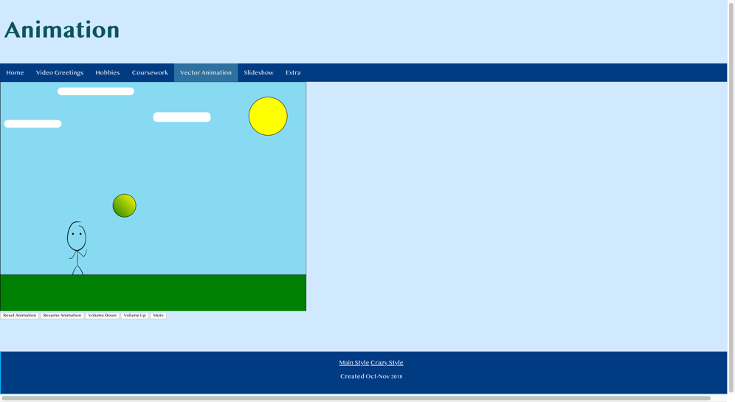

Figure 20 Near the start of the animation

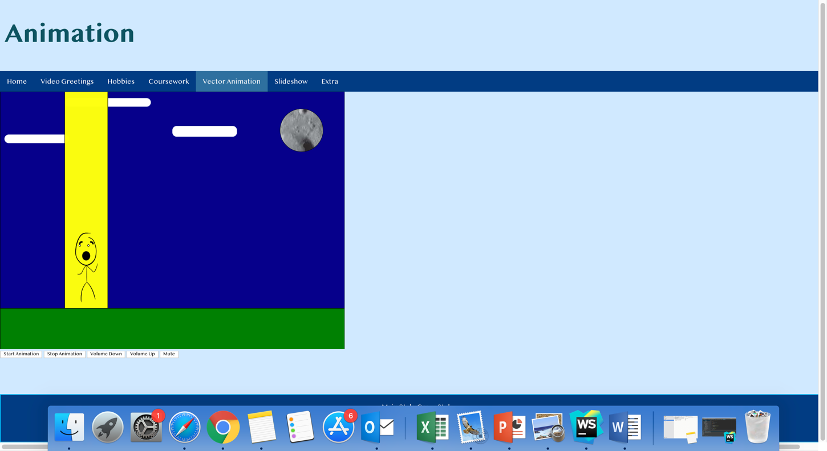

Figure 21 Near the end of the animation

## Conclusion

Basic specification has been met with added features added.

#### Added Features

* Narrative
  + Ball becomes alien 🡪 Alien flies off 🡪 person is abducted
* Realistic behaviour of object
  + Ball bouncing
* Interactivity
  + Play button
  + Stop button
    - Resume button
  + Restart button
  + Mute/Unmute button

# 3 Conclusion

This project (Website and Animation) was successful in that all basic specifications were met. Extra work has been carried out to provide extra functionality to the user.

# 4 References

### UseD to create website:

CSS Website Layout. (2018). Retrieved from <https://www.w3schools.com/css/css_website_layout.asp>

How To Create a Blog Layout. (2018). Retrieved from <https://www.w3schools.com/howto/howto_css_blog_layout.asp>

How To Create a Dropdown Navigation Bar. (2018). Retrieved from <https://www.w3schools.com/howto/howto_css_dropdown_navbar.asp>

How To Create a Slideshow. (2018). Retrieved from <https://www.w3schools.com/howto/howto_js_slideshow.asp>

Johnson, M. (2013). Replacing css file on the fly (and apply the new style to the page). Retrieved from <https://stackoverflow.com/questions/19844545/replacing-css-file-on-the-fly-and-apply-the-new-style-to-the-page>

Carousel. (2018). Retrieved from <https://getbootstrap.com/docs/4.0/components/carousel/>

Coyier, C. (2018). A Complete Guide to Flexbox | CSS-Tricks. Retrieved from <https://css-tricks.com/snippets/css/a-guide-to-flexbox/>

Learn CSS | Codecademy. (2018). Retrieved from <https://www.codecademy.com/courses/learn-css/lessons/css-grid-ii/exercises/justify-content?action=resume_content_item>

Learn CSS | Codecademy. (2018). Retrieved from <https://www.codecademy.com/courses/learn-css/lessons/box-model-intro/exercises/box-model-intro?action=resume_content_item>

Hammon.S | Rollover - ZapSplat - Download free sound effects. (2018). Retrieved 13 November 2018, from <https://www.zapsplat.com/sound-effect-category/rollover/>

Lab 3 – Introduction to Multimedia – University of Sussex

### Used to create animation:

Raphaël Reference. (2018). Retrieved from <https://dmitrybaranovskiy.github.io/raphael/reference.html#Element.animate>

Attaching event handlers to dynamically created JavaScript elements. (2018). Retrieved from <https://toddmotto.com/attaching-event-handlers-to-dynamically-created-javascript-elements/>

HTMLMediaElement.volume. (2018). Retrieved from <https://developer.mozilla.org/en-US/docs/Web/API/HTMLMediaElement/volume>

Lab 4 Tutorial – Introduction to Multimedia – University of Sussex

### Photos used:

Bud, T. (2018). Free Image on Pixabay - Science Fiction, Cover, Futuristic. Retrieved from <https://pixabay.com/en/science-fiction-cover-futuristic-1999495/>

Burner, W. (2018). Solar Eclipse 3a. Retrieved from <https://flic.kr/p/XJok6b>

Free Image on Pixabay - Cartoon, Comic, Dino, Dinosaur. (2018). Retrieved from <https://pixabay.com/en/cartoon-comic-dino-dinosaur-green-1299393/>

Free Image on Pixabay - Pug, Dog, Pet, Animal, Puppy, Cute. (2018). Retrieved from <https://pixabay.com/en/pug-dog-pet-animal-puppy-cute-801826/>

Mittermeier, F. (2018). Blue Universe · Free Stock Photo. Retrieved from <https://www.pexels.com/photo/blue-universe-956981/>

Kingfishers. (2018). Retrieved from <https://www.flickr.com/photos/jez_b/14327297050/>

Free Image on Pixabay - Alien, Cartoon, Character, Comic. (2018). Retrieved from <https://pixabay.com/en/alien-cartoon-character-comic-1295828/>

Ufo free vector icons designed by Pixel Buddha. (2018). Flaticon. Retrieved 13 November 2018, from <https://www.flaticon.com/free-icon/ufo_214358#term=ufo&page=1&position=1>